循环结构作业3

1 用不带循环控制变量的DO循环求下列式（当m≥1000时停止）：
(1)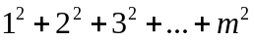
Program ex01a
Implicit none
Integer sum,m,k
Sum=0
M=1
Do
K=m**2
Sum=sum+k
M=m+1
If(m>=1000)exit
End do
Write(*,*) “sum=”,sum
Write(*,*) m
End

(2)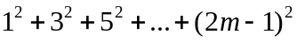
Program ex01b
Implicit none
Real m,k,sum
Sum=0
M=1
Do while m<1000
K=(2m_1)**2
M=m+1
Sum=sum+k
End do
Print*,sum
Print*,m
End

2 设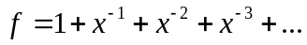，编程求f(x)的前若干项之和，当相邻两项差的绝对值小于10^{－6}即可。
Program ex02
Real x,k,sum
Write(*,*) “x=?”
Read(*,*) x
Sum=1
K=1
Do while(abs(k*x-k)>=1E-6)
K=K/X
Sum=sum+k
End do
Write(*,*) sum
end

3 用牛顿迭代法求方程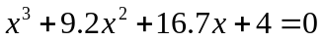在x=0附近的根，精度满足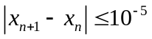时停止迭代，并规定最多迭代50次。牛顿迭代公式为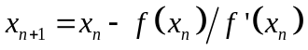。
Program ex03
Implicit none
Real x,I,b
X=0
I=0
Do
b=x-(x**3+9.2*x**2+16.7*x+4)/(3*x**2+18.4*x+16.7)
I=i+1
If(abs(x-b)<10**(-6))then
X=b
exit
End if
X=b
If(i>=50) exit
End do
Print*,x
end
4 课本p117 #2,3,4
Program Ex04b
Implicit none
Integer I,sum
Sum=0
Do i=1,50
Sum=sum+(2*i-1)
End do
Write(*, “(1X,A4,I5)”) “sum=”,sum
End

Program ex04c
Integer i
Real myguess,e,weight
Parameter(e=0.001)
Read(*,*) weight
I=0
Do
I=i+1
If(i>5)then
Print*, “Sorry,you can’t guess any more.”
Exit
End if
Write(*,*)”your guess?”
Read(*,*) myguess
If(abs(myguess-weight)<e)then
Print*, “you are lucky!you are right!”
exit
End if
End do
end

program ex04d
integer i
real sum,k
sum=0
do i=1,10
k=1.0/real(i)
sum=sum+k
end do
write(*,*) “sum=”,sum
end

